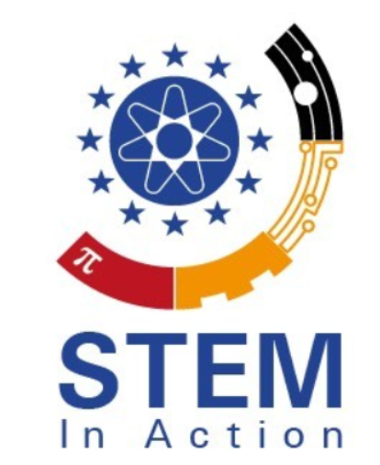
STEMinAction
Open Educational Resources for Teachers
Project Number: 2020-1-TR01-KA203-094309

Social Media Roster
February 2022

University of Paderborn
Jennifer Schneider

Project Title: Open Educational Resources for Teachers
Acronym: STEMinAction
Reference number: 2020-1-TR01-KA203-094309
Project partners: P0 – Tarsus – Tarsus Üniversitesi, TR(Coordinator)
P1 – UPB – University Paderborn, DE (Partner)
P2 – Pi – Pi Privte Company, GR (Partner)
P3 – Unzig – University Of Zagreb Unizg, HR (Partner)
P4 – Vives – Katholieke hogeschool vives zuid, B (Partner)
P5 – UCV – Universitatea din Craiova, RO (Partner)
P6 – CIT – Cork institute of technology, IR (Partner)

Social Media Accounts:
Facebook

P0 – Turkish facebook page:
P1 – German facebook page: https://www.facebook.com/STEM-in-Action-108163131495987
P2 – Greek facebook page:
P3 – Croatian facebook page:
P4 – Belgian facebook page:
P5 – Romanian facebook page:
P6 – Irish facebook page:

Social Media Accounts:
YouTube Channels

P0 – Turkish YouTube Channel:
P1 – German YouTube Channel: STEM in Action - EU - Germany - YouTube
P2 – Greek YouTube Channel:
P3 – Croatian YouTube Channel:
P4 – Belgian YouTube Channel:
P5 – Romanian YouTube Channel:
P6 – Irish YouTube Channel:

Social Media Roster
Month | Organisation | Tasks
February 2022 | UPB | Approx. 3 uploads/ posts and 10 Likes
March 2022 | PI | Approx. 3 uploads/ posts and 10 Likes
April 2022 | Unzig | Approx. 3 uploads/ posts and 10 Likes
May 2022 | Vives | Approx. 3 uploads/ posts and 10 Likes
June 2022 | UCV | Approx. 3 uploads/ posts and 10 Likes
July 2022 | CIT | Approx. 3 uploads/ posts and 10 Likes
August 2022 | Tarsus | Approx. 3 uploads/ posts and 10 Likes
September 2022 | UPB | Approx. 3 uploads/ posts and 10 Likes
October 2022 | PI | Approx. 3 uploads/ posts and 10 Likes
November 2022 | Unzig | Approx. 3 uploads/ posts and 10 Likes
December 2022 | Vives | Approx. 3 uploads/ posts and 10 Likes
January 2023 | UCV | Approx. 3 uploads/ posts and 10 Likes
February 2023 | CIT | Approx. 3 uploads/ posts and 10 Likes
March 2023 | Tarsus | Approx. 3 uploads/ posts and 10 Likes
April 2023 | UPB | Approx. 3 uploads/ posts and 10 Likes
May 2023 | PI | Approx. 3 uploads/ posts and 10 Likes
June 2023 | Unzig | Approx. 3 uploads/ posts and 10 Likes
July 2023 | Vives | Approx. 3 uploads/ posts and 10 Likes
August 2022 | UCV | Approx. 3 uploads/ posts and 10 Likes
September 2023 | CIT | Approx. 3 uploads/ posts and 10 Likes
October 2023 | Tarsus | Approx. 3 uploads/ posts and 10 Likes
November 2023 | UPB | Approx. 3 uploads/ posts and 10 Likes
December 2023 | PI | Approx. 3 uploads/ posts and 10 Likes
All Partners will post January 2024 till the end of the project lifetime | UPB/ PI/ Unzig/ Vives/UCV/ CIT/ Tarsus | Approx. 3 uploads/ posts and 10 Likes

