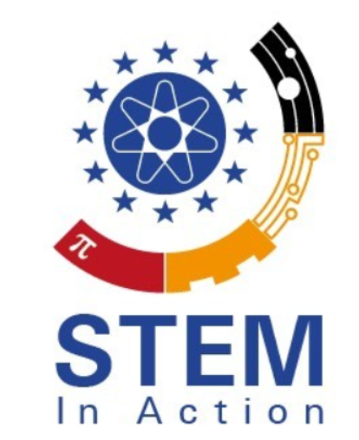
STEMinAction
Open Educational Resources for Teachers
Project Number: 2020-1-TR01-KA203-094309

PRESS RELEASE
January 2022
Organisation University of Paderborn
By Jennifer Schneider

Project Title: Open Educational Resources for Teachers
Acronym: STEMinAction
Reference number: 2020-1-TR01-KA203-094309
Project partners: P0 – Tarsus – Tarsus Üniversitesi, TR(Coordinator)
P1 – UPB – University Paderborn, DE (Partner)
P2 – Pi – Pi Privte Company, GR (Partner)
P3 – Unzig – University Of Zagreb Unizg, HR (Partner)
P4 – Vives – Katholieke hogeschool vives zuid, B (Partner)
P5 – UCV – Universitatea din Craiova, RO (Partner)
P6 – CIT – Cork institute of technology, IR (Partner)

Das STEM in Action Projekt
Project Number: 2020-1-TR01-KA203-094309

Update: Due to the prevailing corona pandemic, the Turkish National Agency has approved the application for an extension and approved an additional project year. The STEM in Action project will therefore only end on December 30, 2023.

The STEM in Action project
STEM in Action is an ERASMUS+ project in the field of higher education. STEM – Science, Technology, Engineering, and Mathematics – is the field that helps children learn how to program, make codes, and understand technological devices. During STEM education activities, students learn in a safe environment that allows them to fall and try again. STEM education stresses the value of failure as a learning exercise, which will enable students to embrace mistakes as part of the learning process. STEM in Action; Open Educational Resources for Teachers is based on Online and Face to Face STEM courses to the teachers free of charge.
The objectives of STEM in Action; Open Educational Resources for Teachers; are
• to exchange good practice across the partner countries through learning raids
• to provide tools, methodologies and approaches to facilitate the acquisition of needed skills
with collaborative learning and teaching environments in STEM
• to increase interest of educators about the priorities to gain the competences that they need around STEM education.
• to develop collaborative partnerships between schools and the universities in formal, nonformal and informal learning
at the aim of strengthening the profile(s) of the teaching profession in EU countries.
• to develop a website incorporating good practices including curriculum materials across partners and a virtual course for teachers
• to produce a range of curriculum materials in STEM area for teachers’ usage
• to upskill teachers in each partner county including knowledge transfer
• to impact on pre-schools, primary, elementary, high schools, VET and university students career choices

Overall, the project divides its results into two intellectual outcomes IO1 and IO2.

IO1: Online STEM Trainer Training Courses
One of the goals within IO1 is to develop learning videos for teachers and students that convey as clearly as possible to this target group how to teach STEM content to their educational target group. Within this framework, the partner consortia each create 10 learning videos for the different school types: pre-school, primary school and branches/vocational schools.
This results in 30 learning videos in English, the content of which can also be translated into the other partner languages ​​using subtitles and can therefore be understood.

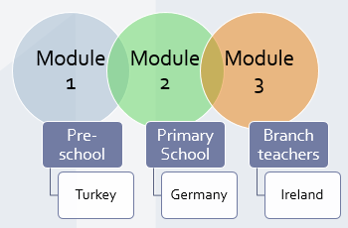

All videos can be found shortly on the STEM in Action YouTube channel:
STEM in Action - YouTube
Link: https://www.youtube.com/channel/UCt0wUJH27UiGKGv8s4poHNA

IO2: STEM Trainer Training Curriculum

The curricular materials aim to support school staff with new and innovative approaches in the area of ​​teaching and learning. The participants are offered pedagogical and didactic approaches with a view to STEM. Here, too, curricula are created for all school types:
Preschool, elementary school and branch/vocational schools.
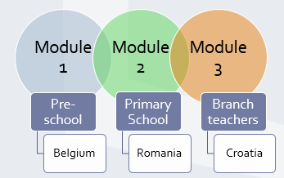

To convey the most important content, employee training is offered in Germany to prepare for the MINT trainer training curriculum as part of a Learning Teaching Training Activity (LTTA for short) II. The meeting will take place in May 2022 at the University of Paderborn.

Until then, we will keep you informed and refer you to our Facebook page

STEM in Action | Facebook

as well as project website:

STEM IN ACTION | Open Educational Recources for Teachers (eduproject.eu)

Stay healthy and all our best,

Your STEM in Action project team Germany

